# **That Girl: Journaling**

### Journaling is a super personalized practice, but one that can help you to become the version of yourself that you see in your mind's eye.

Zoe's avatar

[Zoe](https://substack.com/@zoeffc)

Sep 20, 2024

Share

Hi there!

I had to explain to my boyfriend the other day what “that girl” means. Clearly, I’m chronically online.

Occasionally though, I try to embody my “that girl” energy and journal while I sit at my favorite local bakery with my coffee. This week, I want to talk about my thoughts on journaling and share some journaling inspiration for your weekend.

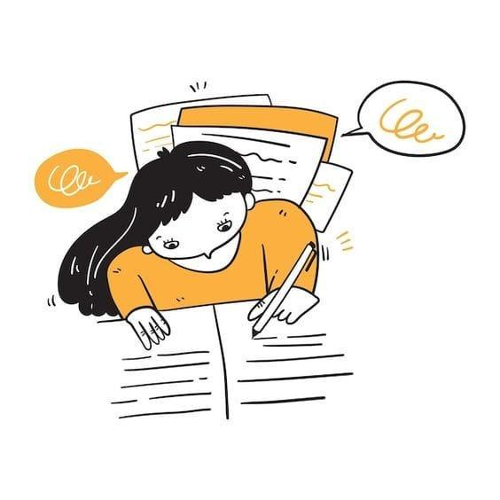

First some housekeeping:

📫 If a friend forwarded you this newsletter (then you have some really cool friends), and you may want to consider joining us here for regular updates.

[Subscribe](https://femme-futures.beehiiv.com/subscribe)

🧲 Got some thoughts you want to share? Join us on Discord to chat all things newsletter and corporate life.

[Discord](https://discord.gg/N84WxemQ?utm_source=femme-futures.beehiiv.com&utm_medium=referral&utm_campaign=that-girl-journaling)

You can find all archived newsletters at the online site, if you ever want to go back or if you just feel like perusing.

[Check out the website](https://femme-futures.beehiiv.com/)

First, let’s define “that girl”. According to Urban Dictionary, “that girl” refers to “a girl (or any gender) that gets up at five a.m., meditates, drinks smoothies, has showers every day, journaling, eating only healthy food, goes to the gym every day and is successful in many ways.”

To be totally up front with you, these vibes are aspirational. No one is always embodying “that girl” energy — but, attempting to connect to that energy can be really helpful. I have found that I can use this energy to push myself to be a slightly better version of myself. One thing that I’ve adopted from embodying “that girl” is the habit of journaling.

I have wanted to be the kind of person that routinely writes in a journal or a diary for my entire life. I actually still have the journals that I started in elementary school (half-filled, lockable diaries with illegible ramblings). My dad, a researcher, always had field notebooks filled with random thoughts and musings that I remember trying to decipher when I was younger. In high school, I tried to adopt the bullet journal method for keeping my life in order and storing my brilliant ideas. I dropped that when I realized that I have very minimal artistic ability. I tried to move away from the artsy approach and keep a utilitarian journal. That worked for a while, but wasn’t a great expressive outlet. Then, a couple of years ago, I caught wind of the notion of Morning Pages.

I believe that this idea was popularized (if not created by) Julia Cameron in her book, *The Artist’s Way.* The idea, which you can read her chapter on [*here*](https://juliacameronlive.com/wp-content/uploads/2011/02/basictools.pdf?utm_source=femme-futures.beehiiv.com&utm_medium=referral&utm_campaign=that-girl-journaling)*,* is that every morning, in an effort to clear your brain clutter and allow space for productivity and creation, you write three-pages of all of your jumbled thoughts. I tried this and LOVED it. I have never been good at habitual writing, and always wrote as if someone would read it. The Morning Pages method allowed me to lower the stakes of my journaling and made it easier to write every day. I also loved the routine of writing first thing in the morning. Having it be something that I did before I even got out of bed made it easier to complete each day. [In total transparency… I wrote *almost* every day, but if you were to flip though my journal, you would certainly find gaps, sometimes a day, sometimes a few weeks. These days, I journal maybe a couple of times a week.]

I find that, when I journal, I am able to work through the thoughts and feelings that seem to dominate my mind. Not to toot my own horn, but I have some pretty good insights. Unfortunately, they are hard to access when I’m freaking out. If I can tame the freakout even slightly, I can access the knowledge that I already have in order to start pulling myself out. An added benefit of this is not snapping at your loved ones that you “know that already!” when you ask them for advice. (I still do this, but at least it’s a little less frequent.)

Ok, so that’s my journaling story. That being said, the best part of journaling is that it is entirely personal. I have friends that prefer a brain dump method throughout the day and ones that prefer a highly structured approach. Some people really like to have journaling prompts and others don’t like to be told what to do. And sometimes you like a different version for a different occasion.

I want to hear how (or if) you journal. Reply to this note with your thoughts, or join the conversation on Discord!

[Discord](https://discord.gg/N84WxemQ?utm_source=femme-futures.beehiiv.com&utm_medium=referral&utm_campaign=that-girl-journaling)

Journal Ideas:

1. Three Good Things (a.k.a. Gratitude). The science is there, we all know it. If you know me in real life, you know that I’m not exactly a ray of sunshine, and gratitude is an effort for me. Especially when I come to journal about the shit that’s bothering me, it is really hard to access any sort of positivity. My practice is to start every single journal entry with Three Good Things. Then I can rant away in peace.
2. Reflect on who you are now, and who you were at this point last year and the year before. I really like doing this one on my birthday, and it is even more fun when you can go back to old journal entries from that time. Over the last couple of years, I have changed a lot and it is kind of crazy to look back at 20-year old Zoe.
3. Fantasize. Imagine an ideal future for yourself. Immediate futures are a little more fun in my opinion because it gives your brain the exercise of figuring out what may be achievable short term goals.

I occasionally end my newsletters with journal prompts relating to the topic *du jour*, so if you are ever looking for inspiration, feel free to dig through the Femme Futures Cooperative archives.

I had a conversation with an old friend recently where we realized that we were both obsessing with being “better” or “good”. I don’t know if that is just a mark of my similarities with this friend, or if it’s a universal experience correlated with being in your 20s. In either case, I hope that you can use some of these thoughts to help you on your journey to be better.

Good luck!

Zoe

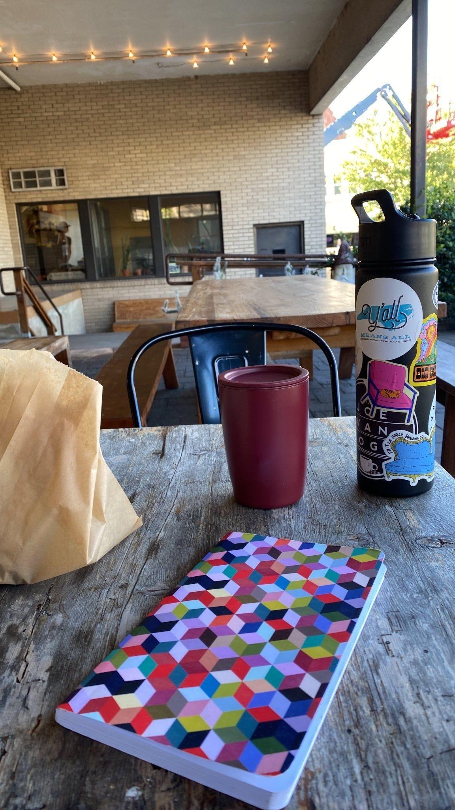

*a moment captured from my “that girl” routine at my current bakery of choice.*

**Femme Futures Cooperative Founding Principles**

💚**Mission**: The mission of Femme Futures is to create a community space for young professionals who identify as over-achievers and activists to generate collective success by providing resources and platforms to thrive in challenging workplace environments.

💙**Vision**: To contribute to a world where driven individuals are equipped with the tools, guidance, and connections to overcome systemic barriers, fully utilize their talents, and enact positive change in their organizations and communities.